Vex go competition



***Our game rules***



# Robot Rules

1. The Robot can only have one Robot Battery
2. The Robot can only have one Robot Brain
3. The Robot can be made of only VEX GO parts
4. The Robot must have the VEX GO license plate with Team Name or Number
5. Decorations are allowed

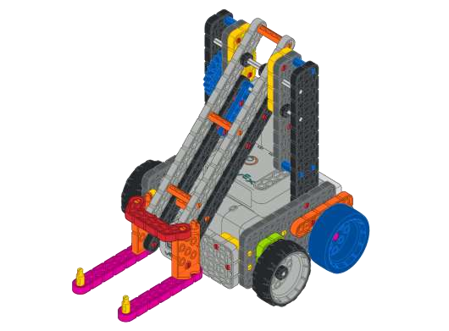

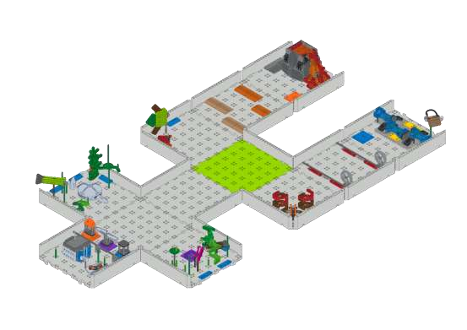

# Game Rules

1. Robots must start on the green tile
2. If a robot becomes stuck, the human player can pick up the robot and place it on an adjacent empty tile
3. There are three ways to play
   1. Solo Driving: 1 team plays a 2 minute match with 1 robot
   2. Solo Coding : 1 team plays a 1 minute match with 1 robot
   3. Coop Driving: 2 teams play a 1 minute match with 2 robots

**How to play ocean science Exploration :**

1. 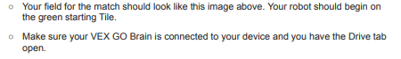Check your field and robot setup:

2.Ocean science Exploration rules :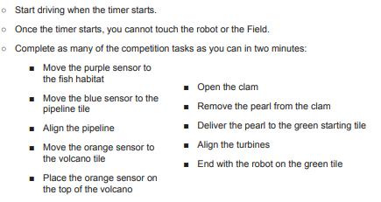



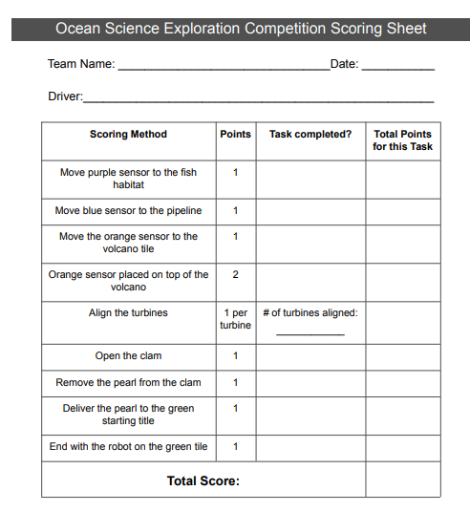ocean science exploration competition scoring sheet (solo driving)

team name :

team number:

Driver :

ocean science exploration competition scoring sheet (solo coding)

team name :

team number:

coders :



ocean science exploration competition scoring sheet (coop Driving )

team name :

team number:

Drivers :



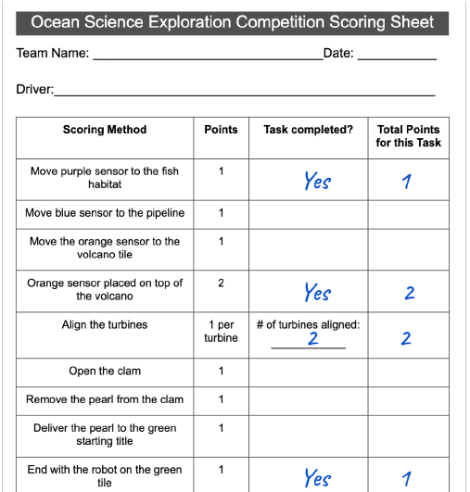

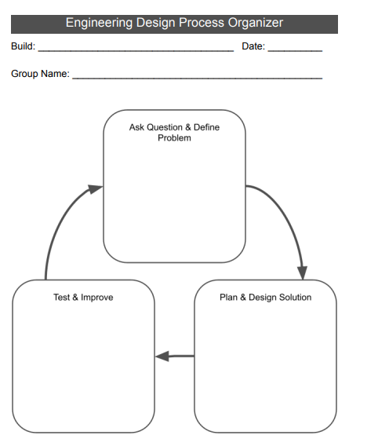

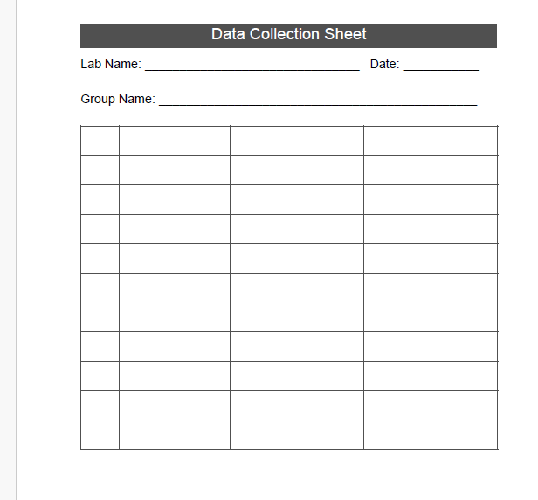

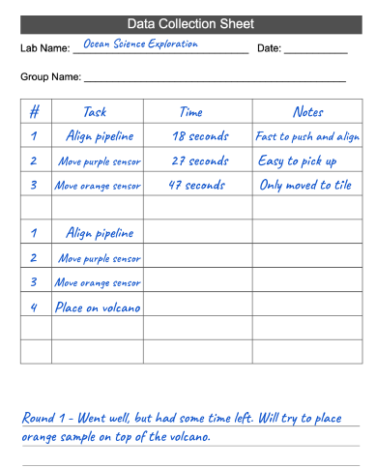

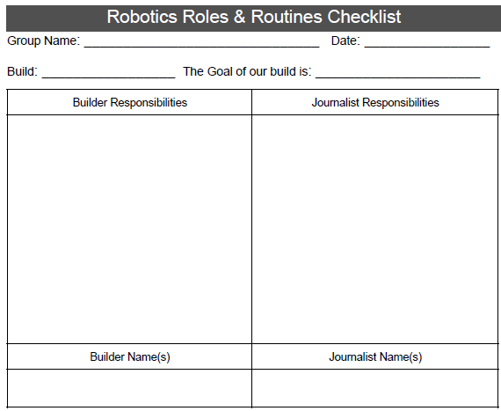

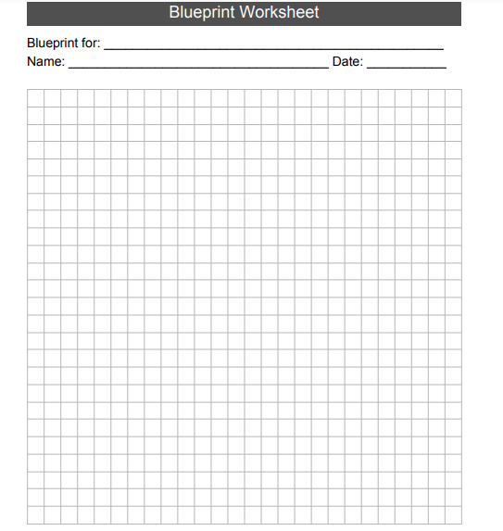

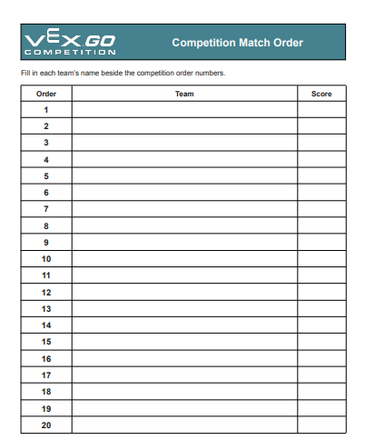

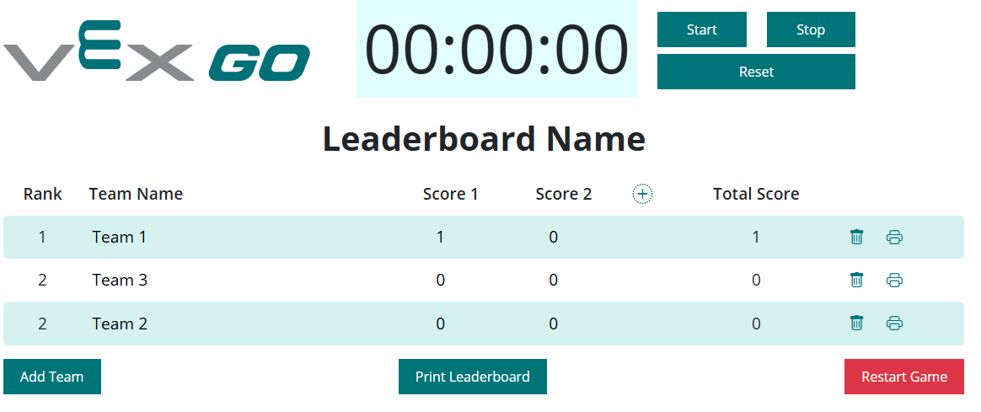

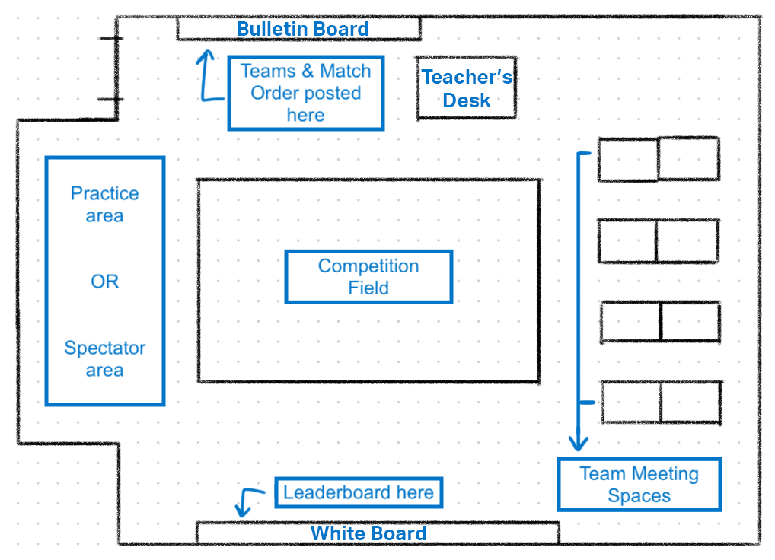

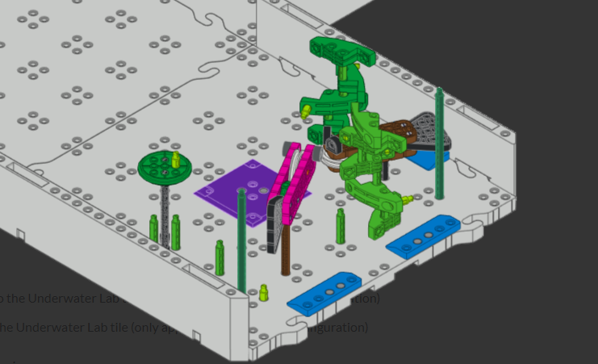

**Zone 1 (Fish Habitat)**

Move the **Environmental Sensor** to **Fish Habitat (Zone 1)**

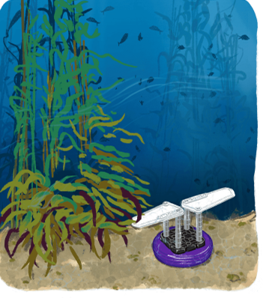

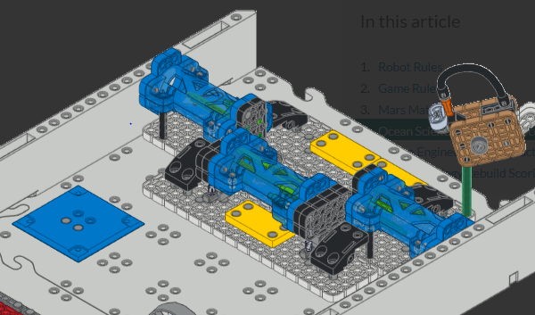

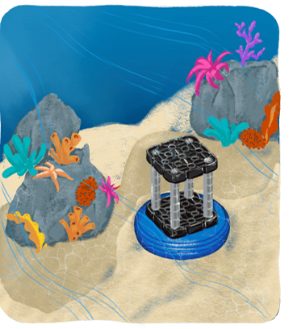

**Zone 2 (pipline tile)**

Move the **Pipeline Sensor** to **Pipeline Tile (Zone 2)**

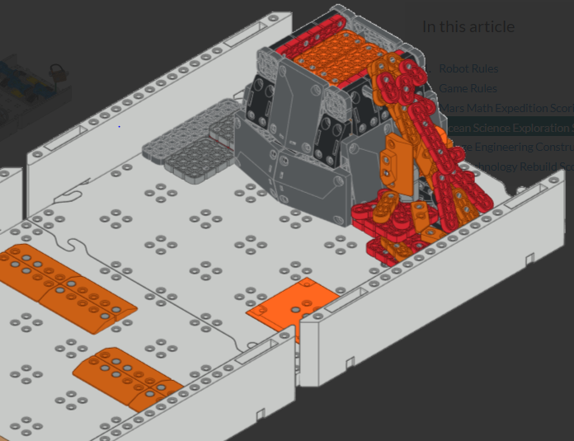

**Zone 3 (volcano tile)**

**Move the** **Volcano Sensor** to **Volcano Tile (Zone 3)**

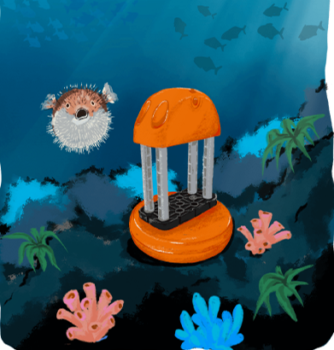

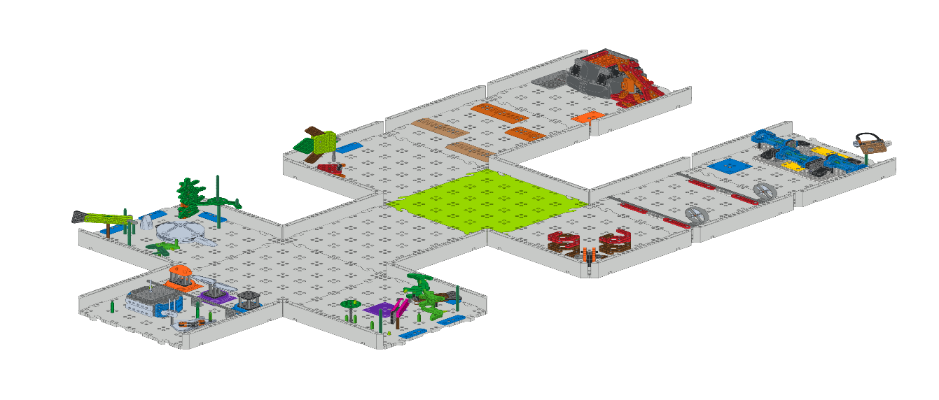

• Start driving when the timer starts.

• Once the timer starts, you cannot touch the robot or the Field.

• Complete as many of the competition tasks as you can in two minutes:

• Move the **Environmental Sensor** to **Fish Habitat (Zone 1)**

• Move the **Pipeline Sensor** to **Pipeline Tile (Zone 2)**

• Align the pipeline

• Move the **Volcano Sensor** to **Volcano Tile (Zone 3)**

• Place the **Volcano Sensor** on the top of the volcano

• Open the clam

• Remove the pearl from the clam

• Deliver the pearl to the green starting tile

• Align the turbines

• End with the robot on the green tile